Table of Contents

1. Introduction 2

2. LOGISTICS MANAGER - Bernice 3

2.1 Background 3

2.2 Actionable Statements 4

2.3 Visuals 5

2.3.1 Delivery Date 5

2.3.2 Summarized Orders 6

2.3.3 Detailed Orders 7

2.3.4 Traffic of Delivery 8

2.3.5 Overall Quantity of Product Types 9

2.3.6 Quantity of Individual Product 10

2.3.7 Location 11

2.4 Dashboard 13

2.4.1 Dashboard 1 13

2.4.1.1 Dashboard 1 explanation 14

2.4.2 Dashboard 2 15

2.4.2.1 Dashboard 2 explanation 16

2.5 Individual Reflection 17

3. Group reflection 18

# Introduction

Logo, company name

https://app.brandmark.io/v3/#logo_data=%7B%22keywords%22%3A%22apparel%22%2C%22id%22%3A%22logo-22b5781a-052a-4873-b34f-2b95d05eee60%22%2C%22layout%22%3A0%2C%22title%22%3A%22Onyx%22%2C%22titleFamily%22%3A%22Abril%20Fatface%22%2C%22titleVariant%22%3A%22400%22%2C%22titleColor%22%3A%5B%7B%22hex%22%3A%22%23eb4c89%22%2C%22location%22%3A0%7D%5D%2C%22titleScale%22%3A2.86%2C%22titleLetterSpace%22%3A3%2C%22titleLineSpace%22%3A1.1%2C%22titleBoldness%22%3A0%2C%22titleX%22%3A0%2C%22titleY%22%3A0%2C%22titleAlign%22%3A%22center%22%2C%22slogan%22%3A%22%22%2C%22sloganFamily%22%3A%22Montserrat%22%2C%22sloganVariant%22%3A%22400%22%2C%22sloganColor%22%3A%5B%7B%22hex%22%3A%22%23eb4c89%22%7D%5D%2C%22sloganScale%22%3A1%2C%22sloganLetterSpace%22%3A0%2C%22sloganLineSpace%22%3A1.1%2C%22sloganBoldness%22%3A0%2C%22sloganAlign%22%3A%22center%22%2C%22sloganX%22%3A0%2C%22sloganY%22%3A0%2C%22icon%22%3Anull%2C%22showIcon%22%3Afalse%2C%22iconScale%22%3A1%2C%22iconColor%22%3A%5B%7B%22hex%22%3A%22%23eb4c89%22%7D%5D%2C%22iconContainer%22%3Anull%2C%22showIconContainer%22%3Afalse%2C%22iconContainerScale%22%3A1%2C%22iconContainerColor%22%3A%5B%7B%22hex%22%3A%22%23eb4c89%22%7D%5D%2C%22iconSpace%22%3A1%2C%22iconX%22%3A0%2C%22iconY%22%3A0%2C%22nthChar%22%3A0%2C%22container%22%3Anull%2C%22showContainer%22%3Afalse%2C%22containerScale%22%3A1%2C%22containerColor%22%3A%5B%7B%22hex%22%3A%22%23eb4c89%22%7D%5D%2C%22containerX%22%3A0%2C%22containerY%22%3A0%2C%22backgroundColor%22%3A%5B%7B%22hex%22%3A%22%23ffffff%22%7D%5D%2C%22palette%22%3A%5B%22%23ffffff%22%2C%22%23eb4c89%22%2C%22%23eb4c89%22%2C%22%23eb4c89%22%2C%22%23eb4c89%22%5D%7D

Onyx, a newly opened online apparel e-commerce shop based in Australia has been in the market for ten months. As data analysts, we will be analysing the data of the company as of 20 November 2021 in this report. As a group of five data we will apply the Design Thinking process to understand the needs of the five respective stakeholders. The five stakeholders are the CEO, the Sales Manager, the Marketing Manager, the Inventory planner, and the Logistics Manager. We will ensure that the visuals created are organized, readable and accessible. Since Onyx is a new company, it has limited manpower. Each stakeholder oversees each department and ensures the company runs smoothly. At the same time, ensuring the company is profiting from the business.

# LOGISTICS MANAGER - Bernice

# Background

The main goal of the Logistics Manager at Onyx is to ensure the smooth and punctual delivery of goods. Our company prides itself on our customer satisfaction and we deliver what is expected of us. As a Logistics Manager, it is important that they know the location of their customers and the order fulfilment delivery date so that they can plan in advance and prioritise the orders in a more efficient manner. Adding on, the Logistics Manager will try to minimize costs for the company by planning the most cost-efficient route that can help to deliver the orders on time. Additionally, the Logistics Manager should also know what the customer has ordered (what product and how many) so their staff can pick and pack the correct items for delivery. Hence, the Logistics Manager is responsible for handling the back-end operations of the store and must be aware of the number of goods I have so I can make space for incoming delivery. They must also liaise with the Marketing and Sales Manager to clear the older stock and inform them of the incoming stock that they have ordered for each season to make space in the warehouse.

Exploratory Questions:

* What is the order fulfilment delivery date? [Refer to 6.3.1]
* What are the orders I need to pick and pack for delivery? [[Refer to 6.3.2](#_Summarized_Orders_(for) for summarised order and refer to 6.3.3 for full order]
* When should my staff deliver the goods? [Refer to 6.3.1 Days Between]
* Which orders should I prioritise? [According to earliest order fulfilment date and when staff should deliver goods]
* When is the next delivery coming into the warehouse? [No Data]
* What products are low quantity and need to be cleared for newer stock? [Refer to 6.3.6 which is a drill through from 7.3.5.]
* Which route can I take to minimise costs yet deliver the goods on time? [No Data]
* Am I able to relocate nearer to larger customer bases to reduce transportation time and costs? [Refer to 6.3.7]
* When are there many deliveries that will be overwhelming for my staff? [Refer to 6.3.4]

# Actionable Statements

A Logistics Manager part of a new local e-commerce company must first establish the company’s reputation for delivering customer satisfaction to gain customer loyalty so that customers will consistently come back to buy our products. This can be done by ensuring the correct deliveries reach the correct customers at the expected date of arrival. Thus, knowing the order fulfilment delivery date and what to pick and pack is extremely vital to build customer trust in the company. With the collated data of the order fulfilment dates, prioritization is the key to delivering orders timely. Prioritization of deliveries will help to ensure a smooth process of picking and packing the most urgent orders and the Logistics Manager’s staff will be able to work more efficiently. After picking and packing the order, based on the customer’s address, the Logistics Manager must figure out a way to deliver their orders on time, whilst taking the shortest route to minimize the costs of transportation to fully maximize the profits the company will be able to achieve.

However, in addition to delivering orders, the Logistics Manger is also responsible for receiving (must know when the new stocks come) and clearing stocks in the warehouse to maximize space and improve the efficiency of picking and packing based on the location and quantity of the stocks.

# Visuals

# Delivery Date

A table is used here, with the columns indicating the Customer ID, Order ID, Order Date and Delivery Date which is used to calculate the Days Between. The Days Between delivery are also highlighted in different shades of blue, with the lightest shade of blue indicating the least number of days between, hence the most urgent orders need to be prioritised. Since the main goal of a Logistics Manager is to deliver orders on time, they must be aware of the delivery date, hence the table is filtered by the earliest delivery date to be satisfied. To ensure timely delivery, a Logistics Manager must be able to prioritise the most urgent delivery dates and arrange the necessary transportation for the orders that have less time to pack. This is therefore clearly stated in the table above.

To ensure our customers keep coming back to us, the role of a Logistics Manager is crucial as they are managing the last portion of customer satisfaction – delivery. Hence to keep up our reputation as a reliable company, I have also included the Days Between column for the Logistics Manager to sort deliveries with long waiting times (e.g., the greater the difference between the order and delivery date, the longer the waiting time for customers) to ensure that our customers receive their orders at an acceptable duration of two weeks at most.

# Summarized Orders

The delivery date has a drill-through page to the summarised orders page where, based on the earliest delivery date of an order (Order ID), the products of the order (Product ID) will be displayed along with the quantity of the products ordered (Quantity). The purpose of this visual is for easy filtering of products during picking and packing. The products in the warehouse are sorted by product code hence, a summarised order is needed for quick access to their location during picking and packing. In the event of a massive order, a total has also been displayed to show the total quantity of products ordered in a customer’s order, this also enhances the readability of the table at a glance.

# Detailed Orders

Following the summarised orders page, it can be drilled through to the detailed customer orders page. The main purpose of this visual is to pick and pack the right orders. After locating the product, the Logistics Manager’s staff needs to know the exact order to take the size, colour and quantity that the customer has ordered. Hence, the detailed customer orders page displays the Order ID from the Delivery page, Product ID and Quantity of products from the summarised orders. For further clarity and fulfilment of the customer’s order, the Product Name and Product Type of the Product ID is displayed as well as the size and colour of the product. The total once again displays the total quantity of the products ordered by Order ID.

# Traffic of Delivery

For the Logistics Manager, ensuring the smooth delivery of products to the customers is fundamental for building customer trust in our company, Therefore, I have created a stacked column chart for the Logistics Manager to track the periods of months in a year where the traffic of delivery is high to mitigate deliveries and plan orders in advance to maximise efficiency during busy periods. Since Onyx has just taken off for 10 months, the traffic of delivery for the month of December is not available.

# Overall Quantity of Product Types

Other than deliveries, a Logistics Manager’s role is not limited to deliveries, but must be always aware of the total quantity of products in the warehouse to facilitate easy movement and management of new incoming stock. This means that the Logistics Manager must know which stocks are low and need to be cleared as soon as possible to free up space in the warehouse. The pie chart is categorised into three slices, each colour of slice representing the three product types (Trousers, Jackets and Shirts) that our company offers. From the pie chart we can see that the quantity of our stocks for each product is around the same. This means that the company sells almost an equal number of product types and as a Logistics Manager, they can monitor the overall quantity of the product types, to ensure that the company has enough stock of a certain product type, ensuring our customers are not deprived of choice.

# Quantity of Individual Product

The quantity of individual products by product name is a drill through from the Overall Quantity of Product Types page and the purpose of the bar charts is to show the quantity of each individual product by product name for the Logistics Manager to know which specific product is running low or has excess stock that needs to be cleared by seasons or releases of new products or product designs. This is also quite important for the Logistics Manager to plan and move the products around such that the fast-moving items are easily accessible at the front of the store, followed by the stocks that have full or almost full quantity. Then the last or broken sizes at the very end for the stocks that have low quantity to maximise the efficiency of the movement of stocks in order to fulfil order requirements smoothly.

# Location

The purpose of using a map is to see which states have the most customers. This map would enable the Logistics Manager to propose an expansion of warehouses in other states or a relocation plan based on states with more customer bases to shorten delivery time, making deliveries more accessible to customers. For a Logistics Manager this is crucial as delivery routes are based on the location of the warehouse and the customer’s address. Having a well-placed warehouse will help to make deliveries more efficient and save costs for the company. I was unable to use the zip code and city of the customers because the data was inaccurate and showed customers from various parts of the world [Refer to image below]. However, we are a small, locally run Australian e-commerce company so our influence has not been spread overseas for customers from various parts of the world to even know or order from the company.

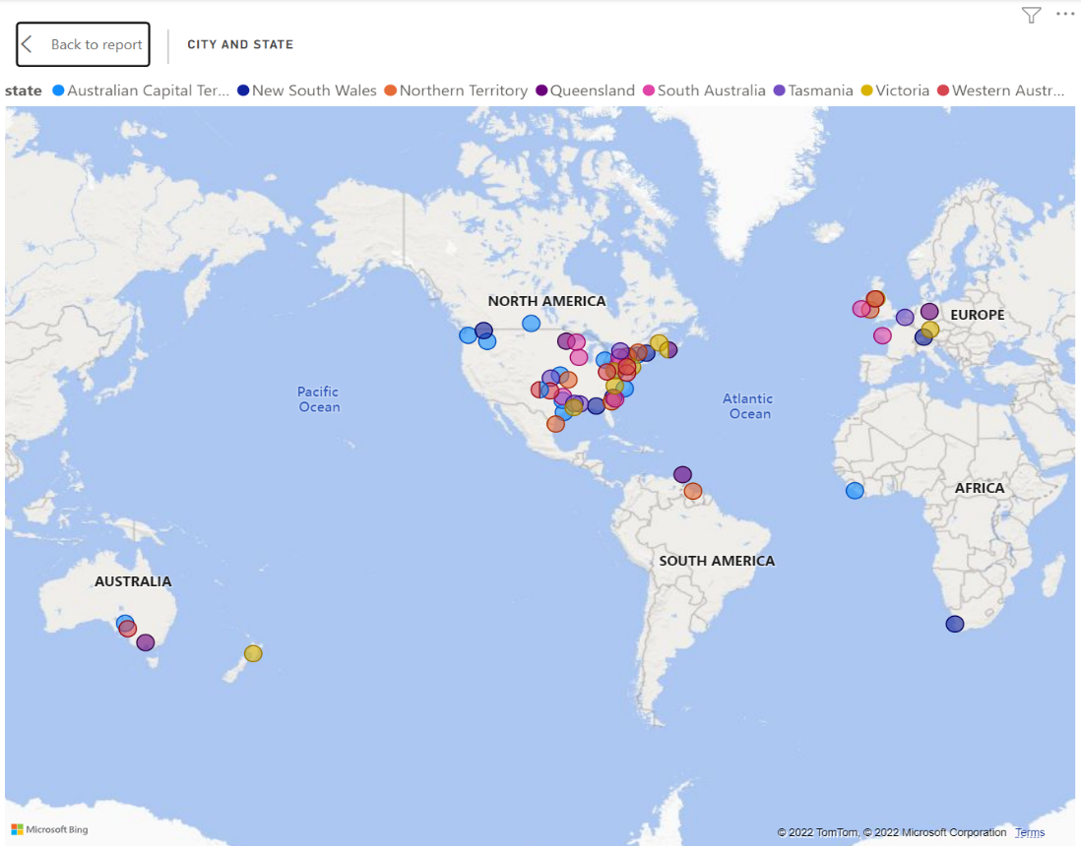

# Dashboard

# Dashboard 1

# Dashboard 1 explanation

For the delivery status dashboard, I decided to consider the following factors fundamental to the delivery of orders to customers. These factors are order fulfilment date, order, and prioritisation of orders. Initially, I considered the addresses of customers as well, but the data was incorrect and thus I was unable to create an accurate visual depicting the location of deliveries.

From the first table, the Logistics Manager can prioritise orders (Order ID) by the earliest order fulfilment date and know the days between the order - the darker shades of blue indicating a long delivery fulfilment date since the date of order; and provide the best customer ordering experience by ensuring that the days between deliveries are shortened to a reasonable 14 days of waiting for customers.

From there, the Logistics Manager would be able to know the products (Product ID) in the orders that the customer placed and the quantity of products in each order.

In the detailed customer orders, the Logistics Manager can focus on each order at a time, with each of the Product IDs, name and type displayed for easy picking and packing of goods. To ensure the most accurate picking and packing, the sizes have also been displayed, with the colour of the products listed to show the customer’s preferences of product.

After the picking and packing of products, the Logistics Manager should be able to know the traffic of delivery for each month to facilitate better planning and arrangement of deliveries should there be many orders to handle.

# Dashboard 2

# Dashboard 2 explanation

This dashboard shows the management of warehouse logistics through three visuals, a pie chart, map, and bar chart.

The pie chart depicts the overall quantity of product types and displays the percentage of these product types for an easy view of the overall inventory.

Below the pie chart, the bar chart displays the total quantity of specific stocks of a product type to track which specific product of a product type is running low so I can plan the placement of the stocks to facilitate the most efficient picking and packing whilst handling the movement of new stock delivery to the warehouse.

The map visual displays the number of customers in a region through the size of the bubbles and this is important to a Logistics Manager as they need to be informed of the places with the most customers so that they can propose a plan to the CEO and suggest either relocation or expansion to an area that is more suited to more of our customers not only to reduce transportation costs but also cater to our customer base in places with more customers so that they can receive their orders maybe even with the option of same day delivery. Alternatively, we could improve the sales of our company by charging a premium for it (express delivery), while keeping transportation costs low.

# Individual Reflection

I have learnt how to arrange data in a way that everyone can understand easily using specific visuals (e.g., table for lots of information, pie chart for data with percentages) and most importantly, I have managed to hone the skill of putting myself in the stakeholder’s shoes to fulfil their needs such as delivery, transportation, and stock placement. The gaps in my learning were identified when I found myself struggling to even produce accurate and appropriate visuals for the storytelling of my stakeholder and my stakeholder’s needs. I realized that I did not fully grasp the concept and role of my stakeholder and impulsively rushed to create exploratory questions without even analysing the given datasets, resulting in a loss of time and much frustration when I was planning which visuals I should choose. This skill of understanding is important because for example, in Programming 1, we are required to write code to solve a problem. But to do that, we must fully understand what the problem is asking of us and what are the next steps that can be taken to resolve the problem. In a work context, since I am working in retail, I also understand the importance of putting myself in the customer’s shoes to fulfil their needs, be it finding a certain product suited for themselves, or resolving issues that the customer faces with our products (e.g., defects, wrong size). The skill of understanding someone is a valuable skill I have picked up through this journey in this module.

# Group reflection

When this assignment was first released, we immediately came up with a timeline for the project. This timeline helps to ensure that the assignment will not be submitted late. We tried to work out schedules with one another, making sure that everyone would not be stressed out by the tremendous workload from the various modules.

At the start of the assignment, we did not manage to do enough research for the respective stakeholders. Furthermore, we did not fully understand the meaning of the various key terms of the data sets. This resulted in us not being able to plan out the exploratory questions that we really need. Additionally, due to the lack of planning, we also had difficulty working out the visuals that we need. For example, the term ‘Sales ID’ was hard to understand even though we searched for its definition. This caused us to be unsure of which values to use for our visuals. Only after we consulted our lecturer, did we know where we had been going wrong. Transforming data to how we wanted it to be was hard too. We needed to use DAX functions to transform and get the values we wanted. For example, the profit of the products. We had to research how to use DAX and code in it.

To get better insights into what the respective stakeholders do, we did a lot of research and recrafted the exploratory questions. From the research of the respective stakeholders, we understood their needs and were able to get a more organized and readable visual. We had an easier time getting the visuals we wanted after diving deep into the stakeholders’ need.

Learning from the mistakes of tutorial five, we decided to host regular meetings to check up on each other’s progress and help one another if they faced any difficulties. After the first draft of the visuals has been crafted, we gave comments for how else we can improve the visuals. We did the project according to the time plan, which was immensely helpful in keeping us in check with our progress.

Through this project, we managed to learn and identify the various needs of the stakeholders, implement new concepts and ideas, tidy and manipulate data as well as design visuals that correspond to our stakeholder needs. This project was particularly challenging but worthwhile as we learned more about business and its workings.